User Guide for the Brochure Generator
Overview
The Brochure Generator is a web application that creates course brochures by scraping course data from a Tertiary Courses website and automatically populating a Google Docs template with the relevant details. The generated brochure includes key information such as the course title, description, learning outcomes, pricing, and other details.
Disclaimer: The generated brochure is not 100% accurate and may have formatting issues. We recommend that you review the document and make any necessary adjustments before using it.
Prerequisites
- Valid Course URL: You must enter a URL from the Tertiary Courses website.
- Google API Credentials: Ensure that your Google API credentials are correctly configured in the Streamlit secrets (under GOOGLE_API_CREDS).
- Google Docs Template: A pre-configured Google Docs template named (Template) WSQ - Course Title Brochure must be available in your Google Drive.
- Internet Connection: A stable internet connection is required for web scraping and API communication.
How to Use the App
- Enter the Course URL:
  - On the left side of the app, input a valid course URL from the Tertiary Courses website in the "Enter the Course URL:" field.
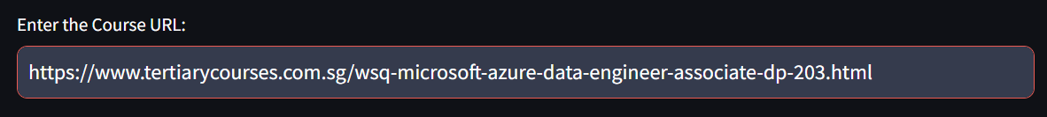
- Generate Brochure:
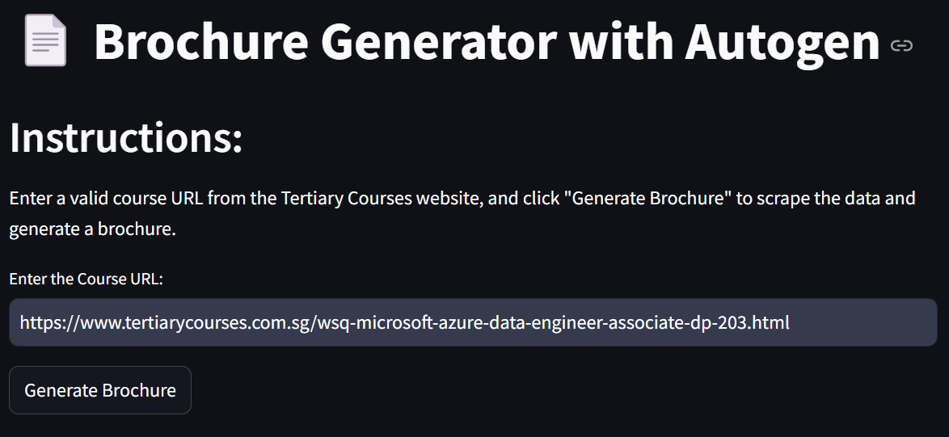
  - Click the Generate Brochure button.
  - The application will scrape the course data from the provided URL.
  - It will then authenticate with Google Drive and check if a brochure for the course already exists.
  - If no existing brochure is found, the app will copy the template and replace placeholders with the scraped data.
- Review Scraped Data:
  - The scraped course data will be displayed in JSON format on the right side of the screen so that you can review the information.
- Access the Generated Brochure:
  - Once the brochure is successfully generated, a shareable link will be provided.
  - Click the "View Brochure" link to open the generated document in Google Docs.
Troubleshooting & Tips
- Invalid URL: Ensure that the URL you provide is valid and belongs to the Tertiary Courses website.
- Existing Brochure: If a brochure for the course already exists, the app will notify you and display a link to the existing document.
- Authentication Issues: Verify that your Google API credentials are set up correctly in your Streamlit secrets. (Dr Alfred’s Google API credentials)
- Performance: Web scraping and document generation may take a few seconds. Please be patient while the process completes.
- Accuracy: As mentioned earlier, the generated brochure might not be 100% accurate and could have formatting issues. Always review the final document.
Support
If you encounter any issues or have questions regarding the Brochure Generator, please contact our support team at support@example.com.
